Project Design Phase
Problem – Solution Fit Template
Date | 15 February 2026
Team ID | SWTID-2026-1597
Project Name | AI Fit Track API – Personalized Fitness Tracking with AI-Powered Insights
Maximum Marks | 2 Marks

Problem – Solution Fit:
The problem-solution fit canvas confirms that the problem we identified – scattered fitness records and a lack of personalised understanding – is real for our users, and that AI Fit Track API solves it in a way that fits their behaviour and constraints.
Purpose:
- Give users one secure place to store all workouts and goals across devices.
- Turn raw numbers into plain-language summaries users can act on.
- Provide recommendations based on each user's own activity rather than generic advice.
- Keep the service dependable through fallback mode and centralised error handling.
Template:
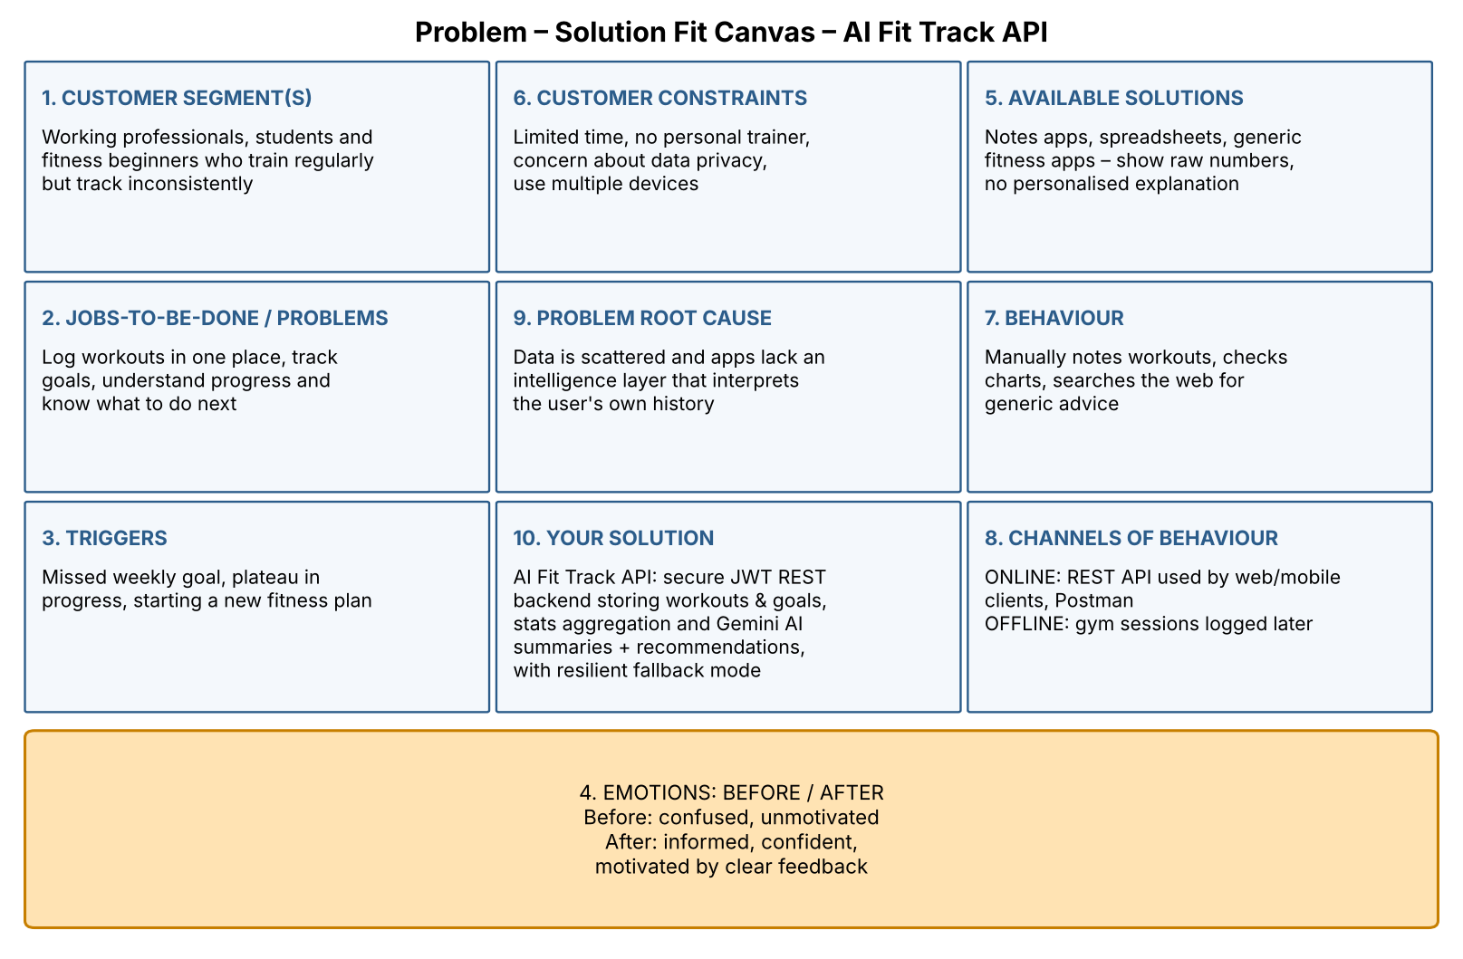
Figure 1: Problem–Solution Fit canvas for AI Fit Track API

